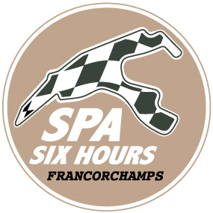

Spa Six Hours/12-16 September 2018

The Pure Historic Racing meeting par excellence!

Undoubtedly the most prestigious meeting of the year on the Spa-Francorchamps circuit, entirely focussed on classic machines of all ages. For its 26th edition the Spa Six Hours will more than ever be devoted to Racing, with a quite awesome programme, series amongst the more sought after in Europe, as also a handful of not to be missed innovations.

“Conversely to other more than respectable manifestations that are mainly based on parades, Spa Six Hours is a meeting exclusively the domain of races for classic machines, Vincent Collard on behalf of Roadbook commented, organisers of an event that has been widely talked about for more than a quarter of a century. And this year, our intention was to place this Pure Historic Racing aspect even more in the limelight. Organising competitions in the field of cars of yesteryear is our speciality … “

Apart from the Spa Six Hours Endurance race traditionally held on the Saturday between 16.00 and 22.00hrs, and bringing together a grid comprised out of 120 cars ranging from the Ford GT40 through to the MG B and including Jaguar E Type, Shelby Cobra, Ford Mustang, Lotus Elan or Porsche 911, the event held in mid-September will not only welcome the different competitions of the Masters series with the spectacular historic F1 single-seaters, the Sports Cars and the Touring cars, but also the more ‘modern’ Endurance Legends. This in addition to such top-rated disciplines as the Woodcote Trophy & Stirling Moss Trophy, the U2TC, the Formula Junior competition, the highly official Jaguar Classic Challenge, etc.

More than ever for this 26th edition, the focus will be on the ‘Pre-War’ machines, and not only during the three days of racing. “In addition to the Historic Grand Prix Cars Association and the superb grid of single-seaters from the ’30s, ’40s and ’50s, we are delighted to welcome the Pre-War Sports Cars, Vincent Collard continued. However, our focus reaches further than merely the ‘race’ aspect, as in close collaboration with our partner, the FBVA, Fédération Belge des Véhicules Anciens, we decided to make Wednesday 12th September a ‘Pre-War Day’, officially christened Pre-War @ Spa Six Hours. The idea is simple: owners of pre-war cars, either racing or road-going, will have the opportunity to cover – at their own pace – laps on the greatest circuit in the world! The aim is to ensure that this ‘Pre-War Day’ becomes widely accepted and part and parcel of the Spa Six Hours, with a Wednesday dedicated to the oldest of the golden oldies. Worth noting that the Pre-War Sports Cars will already be taking on a race on Friday 14th September, over 40 minutes, with the start being given at 17.30hrs.”

More than ever the FBVA will be the privileged partner of these Spa Six Hours, with, beside Wednesday’s Pre-War day, the Warm-Up on Thursday between 18.00 and 19.30hrs (track run for classic cars over 25 years), a P14 parking exclusively reserved for members and therefore classic machines, and the Maison FBVA traditionally set-up in the Salons de l’Eau Rouge throughout the entire weekend.

It is also worth noting the presence in the Endurance Paddock of a Village Vintage, more than ever in harmony with the event.

Access to the Spa Six Hours will set you back 35 euros for the entire weekend in pre-sale (45 euros on site), 20 euros for the Friday and the Sunday (25 euros on site) and 30 euros (35 euros on site) for the Saturday only, which boasts the Spa Six Hours Endurance.

Enthusiasts and aficionados of classic machines, all you need do is to block your mid-September weekend – not forgetting the preceding days – with a view to heading on down to the greatest circuit in the world. Full details: www.spasixhours.com.

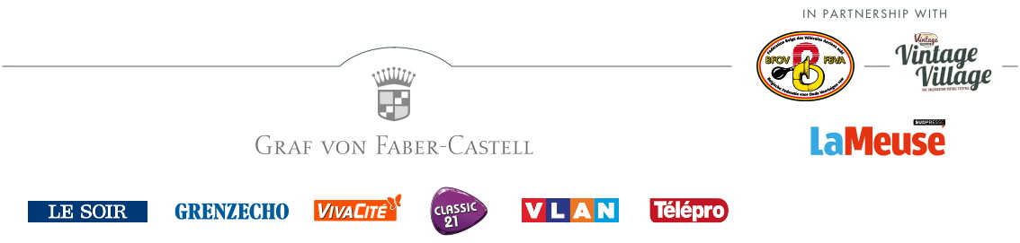
www.spasixhours.com

