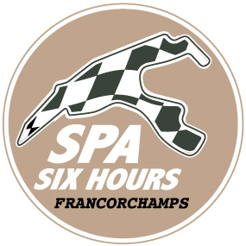

Spa Six Hours / 12-16 September 2018

The meeting of legendary racing machines beckons...

A mere few more times to sleep … If on the one hand it officially kicks-off this coming Wednesday 12th September with the showcasing of the renowned ‘Pre-War’ cars, the 2018 vintage of the Spa Six Hours will on the other hand open its highly important Pure Historic Racing chapter as from Friday 14th September, with two races already programmed on this first day.

One thing is for sure: during three days, the enthusiasts and aficionados will be blown away by an eyeful and earful of machines of yesteryear, the list of entrants in the different competitions brimming over with legendary makes and models that clearly left their mark when it comes to the history of motorsport. Entry lists revealing the presence of personalities and driving professionals, all going head to head on the international historic scene. As such an Eric van de Poele, former F1 driver, five times winner of the 24 Hours of Spa, will be competing in the Spa Six Hours Endurance at the wheel of a… Ford GT40, whilst his son Alexis will be trying his luck with a Ford Falcon Sprint! Also in this race, that gave its name to the meeting, we come across such names as Darren Turner, Marco Seefried, Rob Huff, Gordon Shedden, Nico Verdonck, Ralf Kelleners among others! Final proof that these races for period cars, as also their ever-growing popularity, arouses the curiosity of one and all.

Roadbook, in close collaboration with Graf von Faber-Castell, one of the most reputed manufacturers of writing and drawing instruments and accessories boasting a timeless design, thanks to today’s technological means, offers as top billing the Spa Six Hours Endurance event. The start will be given on Saturday at 15.55hrs and will be more heated than ever! Just imagine, no less than … 16 Ford GT40 will be on hand, with among the favourites Lynn-Haddon-Martin, Tromans-Meaden-Caine, Hart-Hart-Pastorelli, Meins-Lillingston Price-Huff, Wills-Littlejohn, Bryant-Bryant-Cottingham, etc. In the wake of these legendary GT40 machines, the best of the Jaguar E-Type brigade, with notably Clark-McCaig-Smith, Minshaw-Keen and Watson-O’Connell-Kirkaldy, but also the Shelby Cobra muscle cars (with the Belgians Thierry de Latre du Bosqueau and Christophe Van Riet), Shelby Mustang 350GT (of which the Dumolin-Thibaut-Lange trio), Chevrolet Corvette C2, Morgan SLR, TVR Grantura, Ford Falcon Sprint, Aston Martin DB4 GT (the renowned DP214!), Porsche 904, not forgetting the highly original Bizzarrini 5300 GT manned by Muelden, Traber and Seefried! In a nutshell, 360 minutes of on-going thrilling racing …

The rest of the billboard is just as appealing, with the different Masters series, among which the highly official historic F1 of the FIA. The Spaniard Joaquin Folch-Rusinol and his splendid former Nelson Piquet Brabham BT49 will be up against the various Williams FW07C (including that of the Belgian Christophe d’Ansembourg), Lotus 81, Arrows A4 and Tyrrell 011, whereas the March, Hesketh, Shadow, Ligier, Trojan, De Tomaso, Hill and Ensign will add pleasure to a well-filled grid. Single-seaters will also be present in Formula Junior, in former times a stepping stone to F1, where handcrafted makes, sometimes little known or forgotten, crossed swords with the production cars of Lotus, Lola, Brabham and Cooper…

During the Spa Six Hours 2018, there will not be one but two grids set apart for the ‘Pre-War’ machines, with the traditional Historic Grand Prix Cars Association and its Lotus, Brabham, Lister, Ferrari and Scarab joined by the Pre-War Sports Cars, boasting a breath-taking panel of such cars as Bentley, Talbot, Alfa Romeo, Bugatti, Aston Martin, Alvis, Frazer Nash and Lagonda! A 40 minutes race which will take place on Friday in the early evening.

In the Masters Historic Sports Car Championship, the Lola T70 and the Chevron B19 cars will need to come to terms with the Ferrari 512 M of the Brazilian Carlos Monteverde, while the various Shelby Cobra and Cobra Daytona, Jaguar E-Type, TVR Griffith, Bizzarrini 5300 GT and Ferrari 250 GT SWB will reign supreme in the Gentlemen Drivers Pre-66 GT! In addition to this panel the Touring Cars of the Masters Pre-66 TC, ranging from the imposing Ford Falcon Sprint to the Austin Mini Cooper S, or that of the U2TC, with the Alfa Romeo Giulia Sprint GTA, Ford Cortina and BMW 1800, the splendid Jaguar D-Type and C-Type, the various versions of the Lister and Maserati of the combined Woodcote Trophy and Stirling Moss Trophy, the different Jaguar models of the Classic Challenge (C-Type, D-Type, E-Type, MK1, XK) and the most varied grid of the Historic Sports Car Club, ranging from the Lola T282 through to the… Ford Anglia via the Holden Commodore, and you will have covered almost the lot!

Ultimate cherry on the cake of the Spa Six Hours, the Masters Endurance Legends will allow the more recent machines to go head to head, with on the programme an Audi R8 LMP1, a Lola Aston Martin in the Gulf livery (Christophe d’Ansembourg), a Peugeot 908, a Lola B12/60, etc. Undoubtedly enough to delight a younger public …

Without a doubt this is a five-star meeting that Roadbook is inviting you to at the end of this week, a question of borrowing an incredible machine to turn back the time. Further details: www.spasixhours.com.

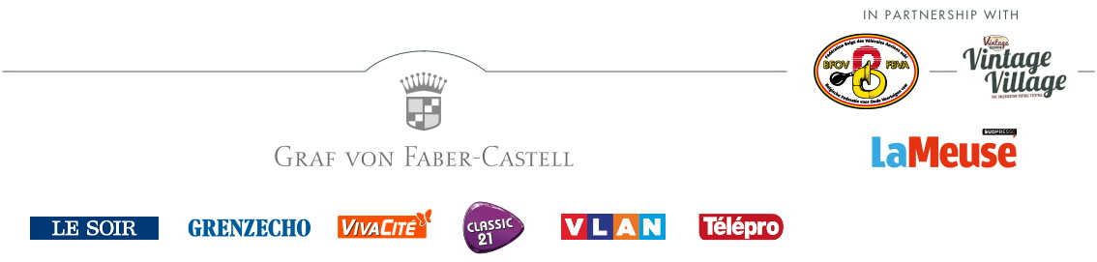
www.spasixhours.com

