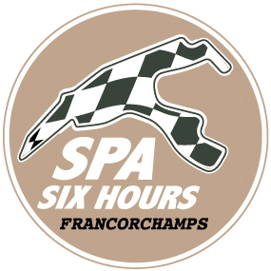
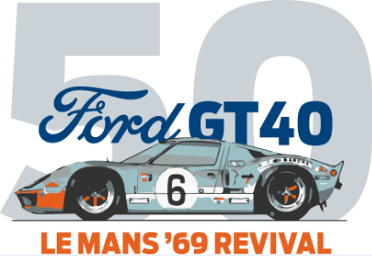
Ford GT40 – Le Mans ’69 Revival
Sint-Agatha-Berchem, 15 May 2019 – In 2019, Ford is commemorating the Ford GT40’s victory in the 24 Hours of Le Mans in 1969. The victory, in which Jacky Ickx played an unforgettable leading role, is so legendary that Ford wants to celebrate that heroic moment fifty years later. It’s doing so not just with a bid by the new Ford GT for victory in the 24 Hours of Le Mans in June, but also with a 1969 Revival, never seen before, at the Spa-Francorchamps circuit in September.
During the Spa Six Hours on Sunday 29 September, Ford will relive the start and finish of the race with no fewer than 50 Ford GTs and GT40s from all three generations! The original race’s start and finish will be re-enacted, with the Ford GT40 ‘Number 6’ in Gulf colours starting last and finishing first a few laps later. An unmissable spectacle!

Legendary start

In the motor racing world you have great victories, and then you have legendary victories that are etched into everyone's memory. Into this latter category falls the victory of the Ford GT in the 24 Hours of Le Mans in 1969, with Jacky Ickx and Jackie Oliver at the wheel. It’s not just the victory itself but the way in which it was achieved that appeals to the imagination.

In the mid-1960s, Ford developed the GT40 with the aim of grinding down the competition in the 24 Hours of Le Mans, in a campaign of sporting revenge against a certain sports car brand from Maranello that had snubbed Ford during takeover talks earlier that decade. After winning the legendary 24-hour race on the Circuit de la Sarthe in 1966, 1967 and 1968, Ford seemed unbeatable with its GT40.

In 1969, however, the race seemed lost right from the start. Jacky Ickx refused to participate in the characteristic ‘Le Mans start’, being unhappy with this downright dangerous procedure in which the drivers had to take their lives into their hands by running over the starting grid to their cars before they could set off. Many drivers also took liberties in this context with the safety rules regarding the use of seat belts, and this had repeatedly led to dangerous situations.

Legendary triumph

Jacky Ickx’s previous calls for the abolition of the Le Mans start had been flatly rejected by the organisers of the 24-hour race. In protest, at the start of the race, he walked sedately to his Ford GT40, buckled himself securely into his racing harness, and was thus the last driver in the field to start.

Ickx’s remarkable action brought him a great deal of admiration and drew attention to the problem of the Le Mans start. But because Ickx had started last with his Ford GT40 (serial number 1075, the same car that had won the Le Mans 24 Hours the previous year), he faced a long series of overtaking manoeuvres during the long circuit. Victory seemed a remote possibility. And yet, after 24 hours of racing with partner Jackie Oliver, he was the first to cross the finish line – barely 120 metres ahead of the second-placed car. He gained a great deal of respect and gave the Ford GT40 its fourth victory in a row.

Spa Six Hours

Fifty years on, the 1969 victory is still one of the most legendary highlights of the 24 Hours of Le Mans. There is therefore every reason to relive that moment.

The collaboration with the Spa Six Hours was no accident. Vincent Collard of Roadbook, the organiser of the event for historic racing cars: ‘With the Spa Six Hours, which we bring to the Spa-Francorchamps circuit every year, we seek to re-create the illustrious history of motor sport. When we heard that Ford wanted to re-enact the Ford GT40’s 1969 triumph in the 24 Hours of Le Mans, I was immediately enthusiastic. After all, no fewer than 20 Ford GT40s take part in our event, which is a sign of the impact the model has had on motor sport history.’

During the Spa Six Hours, the racing legends of the past make their engines roar again and line up against each other in different racing classes. Endurance cars, pre-war sports cars, historic F1s, pre-1966 touring cars,... they all battle it out just as they did in their glory days: it’s an unforgettable spectacle!

See you at the Spa-Francorchamps circuit on September 29.

###

About Ford Motor Company
Ford Motor Company is a global company based in Dearborn, Michigan. The company designs, manufactures, markets and services a full line of Ford cars, trucks, SUVs, electrified vehicles and Lincoln luxury vehicles, provides financial services through Ford Motor Credit Company and is pursuing leadership positions in electrification, autonomous vehicles and mobility solutions. Ford employs approximately 196,000 people worldwide. For more information regarding Ford, its products and Ford Motor Credit Company, please visit www.corporate.ford.com.

Ford of Europe is responsible for producing, selling and servicing Ford brand vehicles in 50 individual markets and employs approximately 49,000 employees at its wholly owned facilities and approximately 63,000 people when joint ventures and unconsolidated businesses are included. In addition to Ford Motor Credit Company, Ford Europe operations include Ford Customer Service Division and 23 manufacturing facilities (16 wholly owned or consolidated joint venture facilities and seven unconsolidated joint venture facilities). The first Ford cars were shipped to Europe in 1903 – the same year Ford Motor Company was founded. European production started in 1911.

Ford in Belgium & Luxemburg
Ford Belgium distributes Ford vehicles and Ford original parts in Belgium & Luxemburg, since 1922.
Ford Lommel Proving Ground is the lead test facility for validation of all Ford models in Europe, with approximately 390 employees.

Contact:
Jo Declercq
Director Communications & Public Affairs Ford Belgium
Tel +32.(0)2.482.21.03
jdecler2@ford.com

