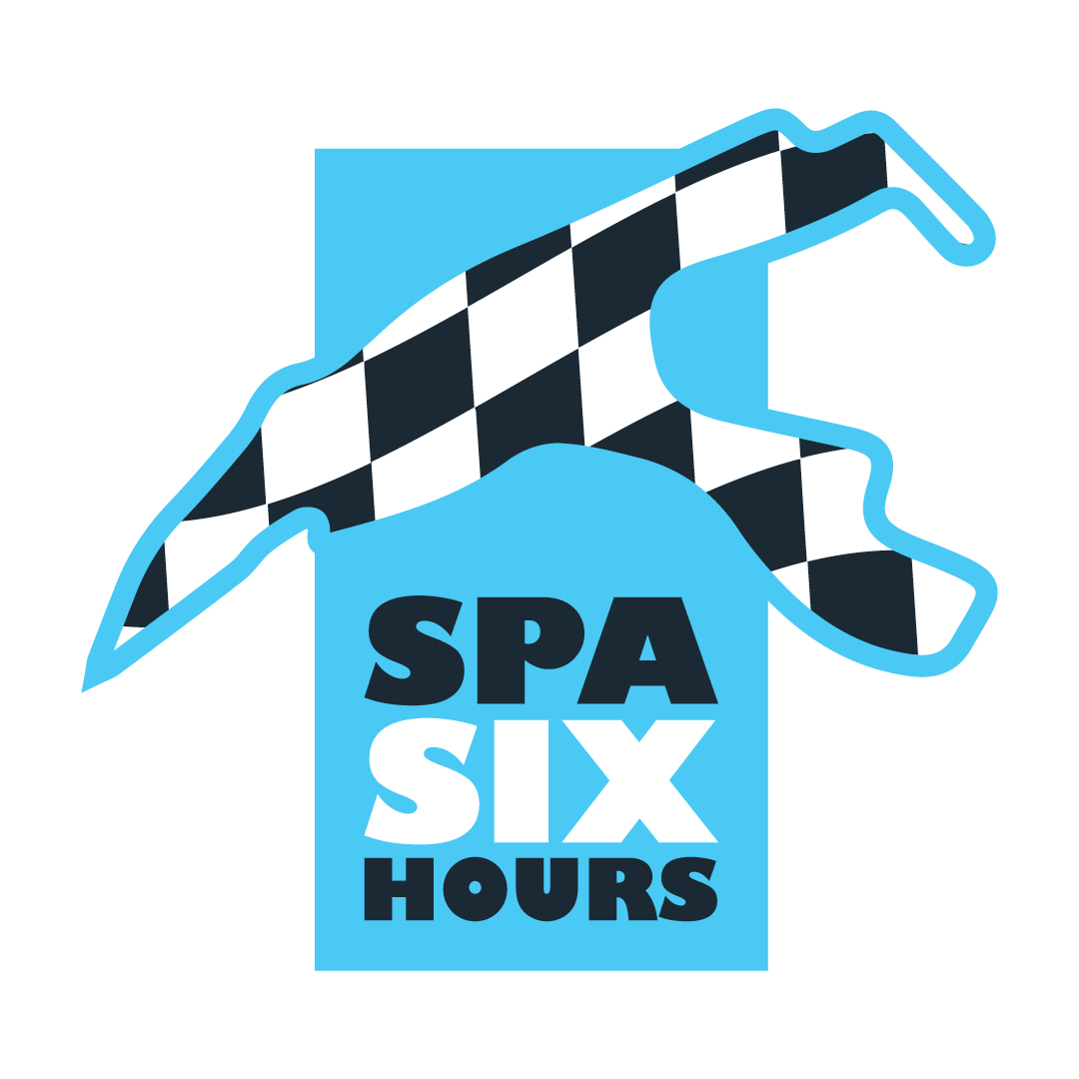
A 30th anniversary celebrated in style

For three days, from Thursday morning to Saturday evening, Spa Six Hours showcased the cars of yesteryear at its 30th edition. On a Circuit de Spa-Francorchamps which was unanimously acclaimed, and which was true to its image in terms of weather, oscillating between heavy rain and bright sunshine, the competitors had a great time, to the delight of a large crowd...
Sport Proto 2000
It was the more modest Sport Proto 2000 line-up which opened the Spa Six Hours late on Friday morning, with a 45-minute race which turned into a demonstration for the Chevron B8s, Chris and Freddy Lilligston-Price taking charge of the first 'God Save the King' sound in the heart of the Belgian Ardennes, by getting the better of Charles Alison on the one hand and Hugh Colman on the other...
Masters Endurance Legends - Race 1
A much more impressive starting grid for the Masters Endurance Legends, which served as a transition between the cars of yesteryear and contemporary competition. In the absence of Christian Gläsel's Pescarolo-Judd, which crashed during qualifying, the race was led in the opening laps by the two Peugeot 90Xs of Steve Brooks and Stuart Wiltshire. The lionesses took the lead until Brooks crashed out at Speaker Corner! After a Safety Car period, Wiltshire took off to win ahead of Olivier Galant's HPD ARX03 and Antoine d'Ansembourg's Dallara Oreca. In the GT category, the Chrysler Viper GTS-R of Christophe Van Riet and Eric Mestdagh led for a long time, before the Aston Martin Vantage GT3 of Claude Bovet and David McDonald took the lead to win...
HGPCA - Pre '66 Grand Prix Cars - Race 1
Race 1 of the Historic Grand Prix Cars Association, featuring pre-1966 Grand Prix cars, had to contend with rain midway through the race. This led to countless pirouettes. While the Cooper T53 and T79 were omnipresent in the provisional top 6, it was Tim Child's Brabham BT3/4 that emerged to win ahead of Michael Gans (Cooper T79), while Rudi Friedrichs (Cooper T53), who had been leading for a long time, encountered gearbox problems at the very end of the race, which sent him back to 3rd place. Among the front-engined cars, the Maserati 250Fs were expected, but John Spiers ended up running off the track at Les Combes, allowing Mark Shaw to win with the very American Scarab Offenhauser, ahead of the two Cooper Bristol Mk2s of Ian Nuthall and Paul Grant.

Masters Racing Legends - F1 Cars 66-85 - Race 1
The rain continued to fall on the starting grid of the Masters Racing Legends, with F1 cars dating from 1971 to 1982. In the game of tyre roulette, some opted for slicks, others for rain tyres. Although poleman Mike Cantillon (Williams FW07C) got off to the best start, the Irishman made a mistake shortly after passing La Source, allowing Nick Padmore (Lotus 711) to take the lead. After a Safety Car period caused by Yutaka Toriba (Williams FW05) running off the track, Cantillon caught up with the leading pack and went on to impose his ex-Keke Rosberg car ahead of Padmore's ex-Gunnar Nilsson Lotus and a Ken Tyrrell (Tyrrell 011) / Werner d'Ansembourg (Brabham BT49) duo separated by... 29 thousandths of a second at the finish line!
Pre-War Sports Cars
Although Justin and Charles Maeers' spectacular GN Parker had taken pole position in the sports cars of the '20s and '30s, technical problems soon sounded the death knell for this original machine. Rudi Friedrichs (Alvis Firefly Special), then Gareth Burnett (Talbot 105), all benefited, as they successively topped the standings... before running into problems of their own! Ross Keeling and Callum Lockie then won their magnificent Delahaye 135 ahead of Christopher Mann's Alfa Romeo 8C Monza and Martin Halusa's Bugatti Type 35!
Belcar Historic Cup - Race 1
So much water! While the weather forecasts were rather optimistic for Friday, a torrential downpour hit the Circuit de Spa-Francorchamps! In these very tricky conditions, the impressive Belcar Historic Cup field experienced some very intense moments, with repeated tyre changes and countless incidents. Having opted for slicks, Guy Fastres (BMW M3 E30) retained the lead until the Bavarian car crashed into the guard rail just before the Double Left corner! With other incidents occurring at the same time, the red flag was waved... and Fastres was declared the winner ahead of Eric Nulens (Porsche 964) and... Italian Ilaria Stalliviera, at the wheel of a modest first-generation Renault Clio equipped with conventional tyres! A few hours later, a salvo of penalties changed the classification once again, and it was Ilaria Stalliviera who was declared the winner! Michel Kowaleski (Ford Escort Mk2) won the Oldtimers category ahead of Eric Damseaux (Mini Cooper S) and Britain's Harry Barton (BMW 2002)! Improbable...
Masters GT Trophy
It was also in the rain that the Masters GT Trophy competitors came to blows late on Friday. The Lamborghini Huracan Super Trofeo started off as favourites, and they completed the double, Craig Wilkins winning ahead of the Chris Milner-Nigel Greensall duo, the podium being completed by the Lotus Elise Motorsport of Rob Fenn and Paul Wright. In the GT4 category, victory went to Hans Hugenholtz in a Ford Mustang FR500C.
Masters Gentlemen Drivers & Pre-66 Touring Cars
Saturday began with a 90-minute semi-endurance between some Jaguar E-Type, TVR Griffith and Shelby Cobra Daytona. Starting from pole position, John Spiers' TVR held on to the leading group, before Nigel Greensall propelled himself to the top of the standings to take a superb victory ahead of the Jaguar E-Type of Gary and John Pearson and the Lotus Elan 26R of Giles Dawson, winner in the less than two litres category. In the touring car category, which battled it out for 60 minutes, Sam Tordoff won with authority in his impressive Ford Falcon Sprint, ahead of the Ford Mustang of Jake Hill and Rob Fenn, and the Ford Falcon of Richard McAlpine.
HGPCA - Pre'66 Grand Prix Cars - Race 2
After the victory of Tim Child's Brabham BT3/4 the day before, the Coopers took a dazzling revenge on Saturday, on a track that was finally dry. And it was the Luxembourger Michael Gans who took the lead, taking a fine victory with the Cooper T79, whose racing career in the early '60s was more than limited. Gans held off Justin Maeers' Cooper T53 to the finish, while Briton Andy Middlehurst, in an ex-Jim Clark Lotus 25, got the better of Tim Child, whose car suffered engine problems. A Maserati 250F made a comeback in the front-engined category, with John Spiers winning ahead of the two Cooper Bristol Mk2s of Ian Nuthall and Paul Grant.
Masters Endurance Legends - Race 2
The Belgian national anthem sounded on the Circuit de Spa-Francorchamps on Saturday morning at the end of Race 2 of the Masters Endurance Legends. While his father Christophe d'Ansembourg was unlucky on Thursday to miss out on the rest of the weekend, Antoine d'Ansembourg lived up to the pedigree of his ex-Didier Theys Dallara-Oreca to win Race 2 of the Masters Endurance Legends, ahead of the Lola-Judd of Briton Steve Tandy and the Zytek 09S of Canadian Keith Frieser. In the Grand Touring category, another win for the Aston Martin Vantage GT3 of Swiss driver Claude Bovet and Briton David McDonald, who again beat the Chrysler Viper GTS-R of Belgian drivers Christophe Van Riet and Eric Mestdagh.
Belcar Historic Cup - Race 2
After the poor weather conditions of the previous day, the Belcar Historic Cup finally benefited from optimal conditions for its second race. That was all it took for the powerful Ford Capri 3100 RS of Dutchman Wim Kuijl to climb back up the field and take the overall lead from the Corvette C4 of Belgian Luc Branckaerts, who won for the first time in the Youngtimers category. The American beauty was ahead of the superb BMW 320i E36 STW driven by Erik Qvick and the Porsche 964 driven by Luc Moortgat. In the Oldtimers category, behind overall winner Wim Kuijl were Angelo Ferrazano's Porsche 911 RSR and Dieter Kuijl's Ford Capri 2600 RS...
Masters Sports Car Legends
The Lolas were the queens of the Masters Sports Cars Legends at the Circuit de Spa-Francorchamps, even though American Kyle Tilley played the spoilsport with his Chevron B23. Unfortunately, brake problems propelled the car into the Combes breakaway, before it retired to the pitlane. Having taken over from Portugal's Diogo Ferrao in his Lola T292, Briton Martin Stretton managed a Safety Car period at the end of the race to take victory ahead of the Lola T70s of Jason Wright and the Stephan Joebstl-Andy Willys duo. Alexander Furiani took 4th place, alongside Belgian François Fabri in a Chevron B19.
Masters Racing Legends F1 Cars 66-85 - Race 2
And a second Belgian national anthem, and another d'Ansembourg! After Antoine's victory in the Masters Endurance Legends, it was Werner who totally dominated Race 2 of the historic F1 cars at the wheel of the ex-Nelson Piquet Brabham BT49, in front of the Tyrrell 011 of American Ken Tyrrell and the Williams FW07-C of Irishman Mike Cantillon. In the non-ground-effect single-seaters category, it was Nick Padmore's Lotus 77 that took another victory, well ahead of Ewen Sergison's Surtees TS9B.
Spa Six Hours Endurance
Nearly twenty Ford GT40s on the grid, 15 of them at the top of the standings a third of the way through the race... and only one able to beat the best Lotus Elan 26R at the end of the event! There was no doubt that the Spa Six Hours Endurance was true to tradition, with an abundance of race incidents and other twists and turns. Over the course of the eight Safety Car periods that punctuated the race, a number of top teams, including Bryant-Cottingham (#21), Hart-Hart-Pastorelli (#8), Ditting-Hancock (#3) and Pearson-Brundle (#2), disappeared from the upper echelons of the standings, leaving the limelight to Andy Priaulx, Gordon Shedden and Miles Griffith (#14), as well as Nico Verdonck and Marcus Graf Oeynhausen (#30). Brake problems slowed down the Belgian-German duo towards the end of the race, allowing the Ford GT40 driven by multiple European and World Touring champion Andy Priaulx to take the win... ahead of the #600 Lotus Elan 26R of Andrew Jordan, Sam Tordoff and James Dorlin! It was the 16th victory for a GT40 in 30 editions of the Spa Six Hours Endurance.
In the final laps, Tony Wood, Will Nuthall and Michael Lyons (#25 Ford GT40) managed to complete the top 3. As for the weekend's world stars, seven-time NASCAR champion Jimmie Johnson and three-time Indy 500 winner Dario Franchitti, teamed up with Marino Franchitti, they had a long claim on the final podium before failing to finish 7th in the #32 Ford GT40. The first Jaguar E-Type, the #33 of Jon Minshaw and Phil Keen, was only to be found in 9th place.
The Touring category was won by the Ford Mustang driven by Dutchmen Jac and Ties Meeuwissen and Bas Jansen, who beat the Ford Falcon Sprint driven by Vanina Ickx! Luxembourgers Bob Kellen, Yann Munhowen and Max Schiltz (Mustang) completed the podium.
In the other categories, there were wins for Jordan-Tordoff-Dorlin (Lotus Elan - GTS10), Orebi Gann-Bourne-Lockie (Morgan +4, GTS11), Minshaw-Keen (Jaguar E-Type, GTS12) and Bordet-Bordet (Marcos 1800 GT, GTP -2.5 litres). Nico Verdonck, the best Belgian driver, was awarded the Prix Jean Blaton - Beurlys.
www.spasixhours.com
Free of rights pictures : Roadbook – Braconnier Agency
Dropbox Roadbook Media: https://www.dropbox.com/scl/fo/dhskc0kak5pwqgxzm5ueo/h?rlkey=z2ppxv36t63i7dujxmmgwd1ib&amp;dl=0

